(Approx. 703 words)

Inkjet Printer Ink Cartridges
by Jeff Wilkinson, President, Sun City Summerlin Computer Club
https://www.scscc.club
pres.scscc (at) gmail.com
There are two methods of ink deposition that are widely used in household inkjet printers: thermal bubble and piezoelectric.

Thermal Bubble Printing

Inkjet printing technology was proposed as early as 1960 and became commercially available in the early 1980s in the Canon Bubblejet and the HP Digital Printer. In March 1993, Epson entered the inkjet printer market with Micro Piezo inkjet technology using a piezoelectric crystal in each ink nozzle.

With the bubblejet technology, current is passed through a resistor in the nozzle path, heating the ink, vaporizing it, and depositing a small amount of ink on the media. As a result, a slight vacuum is created, drawing more ink into the nozzle for the next cycle. This happens as often as 36,000 times per second.

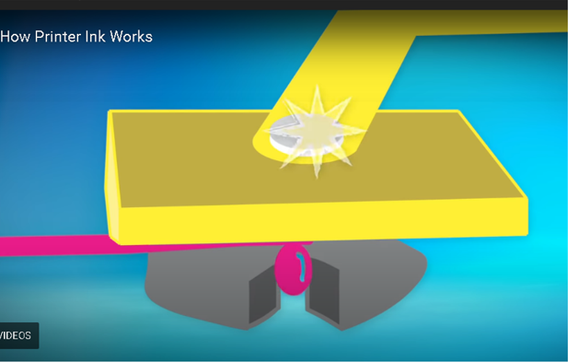

Using "bubblejet" technology, the typical ink cartridge has hundreds of tiny holes or nozzles, about 15 microns in size. The precision digital manufacturing process ensures the nozzles are correctly sized and placed on the printhead for correct placement of the ejected drops. As small as 4-picoliters, the tiny ink drops are launched through these precision nozzles. A picolitre is a millionth of a millionth of a liter! As many as 32 drops of ink are used to produce each color dot, and images may contain thousands upon thousands of dots. Therefore, the chemical formulation of the ink is very important, and poorly formulated inks may cause clogging or oxidation on the printhead nozzle.

Partially because of the complexity and development costs and a somewhat captive market, the price of inkjet cartridges was initially quite high. This spawned a compatible cartridge market in which vendors, big and small, qualified and not so qualified, began offering replacement inkjet cartridges. However, their only option was to refill inkjet cartridges with the existing patents since a replacement could not be legally manufactured. This created a secondary market for empty inkjet cartridges with various recycling and collection schemes used to get cartridges to refill.

As the compatible market matured, the OEM manufacturers added protection in the form of a semiconductor chip used to prohibit non-OEM cartridges. Of course, workarounds appeared almost immediately, and the back and forth battle has been going on for many years. There is no question the best quality comes from OEM ink cartridges. Still, many users feel that the cost/quality ratio is too high for everyday printing and opt for compatible cartridges. Furthermore, since the printing functionality comes almost entirely from the cartridge, a faulty cartridge can be replaced and renew the entire imaging system.

Piezoelectric Printing

Epson inkjet printers use the piezoelectric process in their printers. With this process, the printer contains the printheads rather than the printheads being part of the cartridge. Printheads have a piezoelectric element in the printer that contracts when a voltage is applied. The element and vibration plate move, much like the loudspeaker's cone, and force out a precise amount of ink out of the nozzle.

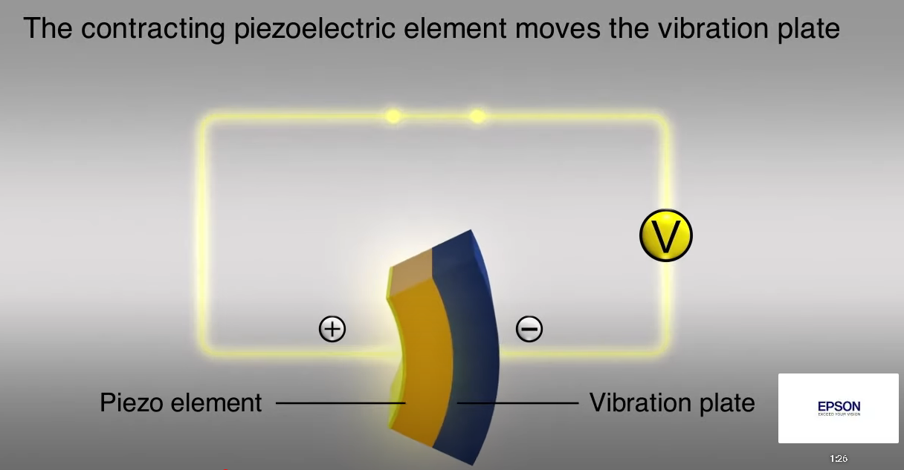

This eliminates the need to heat the ink to create a bubble, reducing the complexity of the ink formulation. Printheads with 128 black nozzles and 192 color nozzles (64 for each color) produce a resolution of 720 dpi, for example.

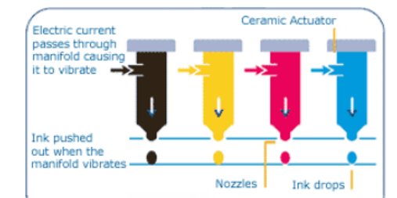

Since the ink does not need to be heated, it can be tailored to the media to which it is applied, in many cases giving more flexibility to the ink formulation.

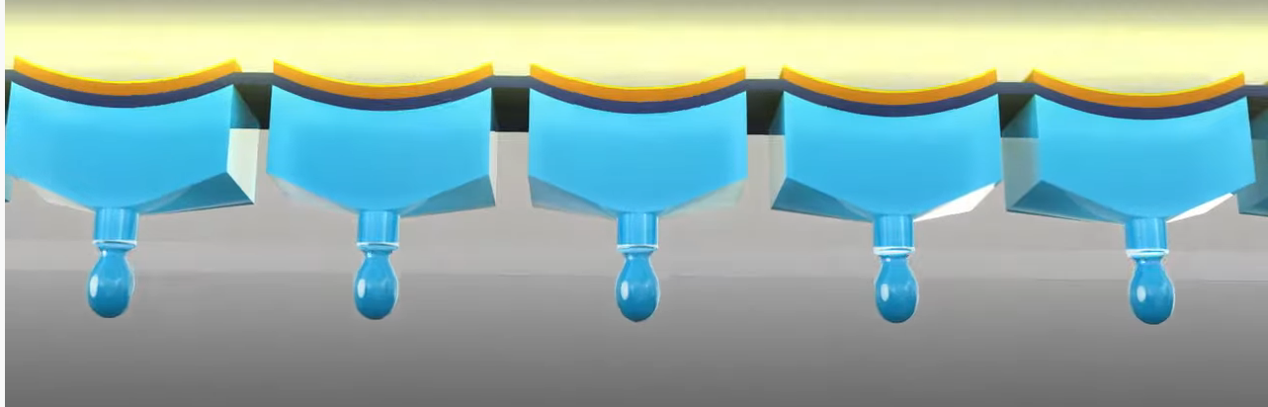

The internal printheads contain rows of these elements, which fire at precisely the right time, releasing the correct amount of ink as many as 40,000 times per second!

Since the ink cartridges for these printers do not contain the printhead, they are easier to duplicate, and many compatible cartridges are available. However, once again, the manufacturer has countered these efforts with onboard chips which warn you about the use of third-party inks.

Printer manufacturers have made numerous attempts to use firmware and onboard chips that won't allow the use of third-party inks and multiple corresponding class-action lawsuits against these actions.

Each user has to choose which ink cartridges to use but armed with some understanding of the printer ink systems you can add, make a more informed decision.

